
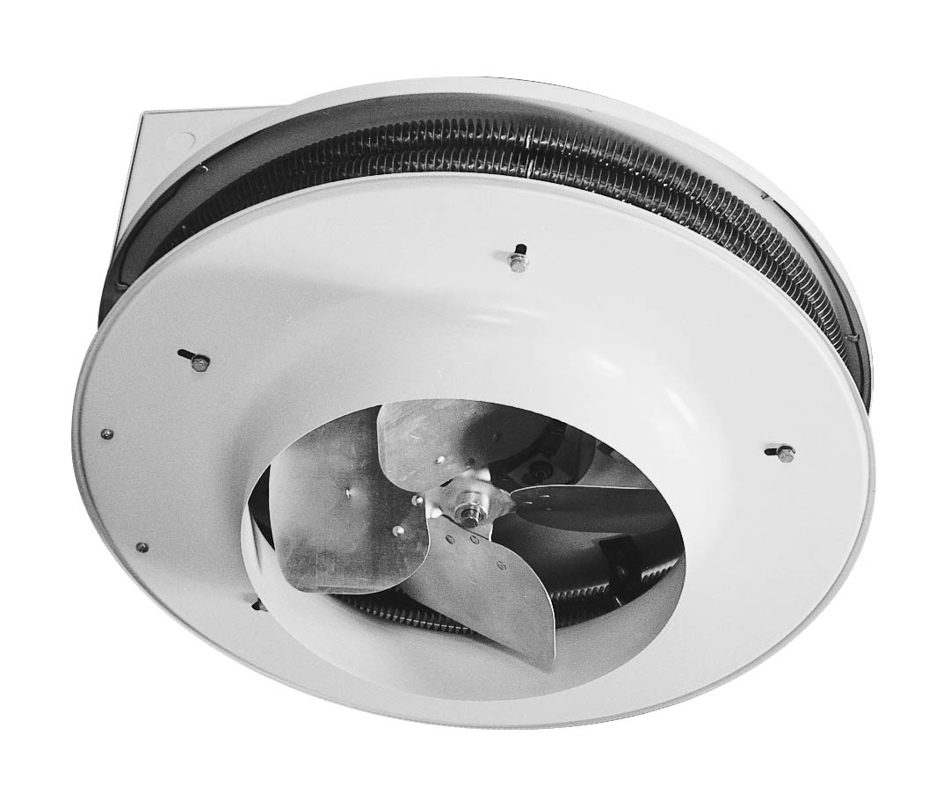

KW | Volts | Phase | Total  Amps (1) | CFM | Approximate Air Temperature Rise ºF (ºC) | Motor Data |  |  | Weight  lb (kg) | Catalog  Number
 |  |  |  |  |  | HP | RPM | Voltage | Weight  lb (kg) | Catalog  Number
3.2 | 480 | 3 | 4.7 | 450 | 22 (12) | 1/25 | 1050 | 208/240 | 75 (34) | HX-928C03200UA
4.8 | 480 | 3 | 6.6 | 450 | 34 (10) | 1/25 | 1050 | 208/240 | 75 (34) | HX-928C04800UA
5 | 208 | 1 | 24.9 | 450 | 36 (20) | 1/20 | 1050 | 208/240 | 75 (34) | HX-928C05000CA
5 | 208 | 3 | 14.7 | 450 | 36 (20) | 1/20 | 1050 | 208/240 | 75 (34) | HX-928C05000DA
5 | 240 | 1 | 21.7 | 450 | 36 (20) | 1/20 | 1050 | 208/240 | 75 (34) | HX-928C05000JA
5 | 240 | 3 | 12.9 | 450 | 36 (20) | 1/20 | 1050 | 208/240 | 75 (34) | HX-928C05000KA
6.4 | 480 | 3 | 8.6 | 600 | 34 (19) | 1/20 | 1050 | 208/240 | 75 (34) | HX-928C06400UA
7.5 | 208 | 3 | 21.7 | 600 | 40 (22) | 1/20 | 1050 | 208/240 | 75 (34) | HX-928C07500DA
7.5 | 240 | 1 | 32.1 | 600 | 40 (22) | 1/20 | 1050 | 208/240 | 75 (34) | HX-928C07500JA
7.5 | 240 | 3 | 18.9 | 600 | 40 (22) | 1/20 | 1050 | 208/240 | 75 (34) | HX-928C07500KA
9.6 | 480 | 3 | 12.5 | 1200 | 25 (14) | 1/6 | 1140 | 208/240 | 75 (34) | HX-928C09600UA
10 | 208 | 3 | 28.6 | 750 | 41 (23) | 1/20 | 1050 | 208/240 | 75 (34) | HX-928C10000DA
10 | 240 | 1 | 42.5 | 750 | 41 (23) | 1/20 | 1050 | 208/240 | 75 (34) | HX-928C10000JA
10 | 240 | 3 | 24.9 | 750 | 41 (23) | 1/20 | 1050 | 208/240 | 75 (34) | HX-928C10000KA
12.8 | 480 | 3 | 16.3 | 1200 | 34 (19) | 1/6 | 1140 | 208/240 | 100 (48) | HX-928C12800UA
15 | 208 | 3 | 43.4 | 1200 | 40 (22) | 1/8 | 1140 | 208/240 | 100 (48) | HX-928C15000DA
15 | 240 | 1 | 64.3 | 1200 | 40 (22) | 1/8 | 1140 | 208/240 | 100 (48) | HX-928C15000JA
15 | 240 | 3 | 37.9 | 1200 | 40 (22) | 1/8 | 1140 | 208/240 | 100 (48) | HX-928C15000KA
16 | 480 | 3 | 20.2 | 1600 | 32 (18) | 1/6 | 1140 | 208/240 | 100 (48) | HX-928C16000UA
19.2 | 480 | 3 | 24 | 1600 | 38 (21) | 1/6 | 1140 | 208/240 | 100 (48) | HX-928C19200UA
20 | 208 | 3 | 57.3 | 1600 | 40 (22) | 1/8 | 1140 | 208/240 | 100 (48) | HX-928C20000DA
20 | 240 | 1 | 85.1 | 1600 | 40 (22) | 1/8 | 1140 | 208/240 | 100 (48) | HX-928C20000JA
20 | 240 | 3 | 49.9 | 1600 | 40 (22) | 1/8 | 1140 | 208/240 | 100 (48) | HX-928C20000KA
25 | 208 | 3 | 71.2 | 2000 | 40 (22) | 1/8 | 1140 | 208/240 | 100 (48) | HX-928C25000DA
25 | 240 | 1 | 106 | 2000 | 40 (22) | 1/8 | 1140 | 208/240 | 100 (48) | HX-928C25000JA
25 | 240 | 3 | 61.9 | 2000 | 40 (22) | 1/8 | 1140 | 208/240 | 100 (48) | HX-928C25000KA
30 | 208 | 3 | 85.1 | 2300 | 41 (23) | 1/8 | 1140 | 208/240 | 100 (48) | HX-928C30000CA
30 | 240 | 1 | 126.8 | 2300 | 41 (23) | 1/8 | 1140 | 208/240 | 100 (48) | HX-928C30000JA
30 | 240 | 3 | 74 | 2300 | 41 (23) | 1/8 | 1140 | 208/240 | 100 (48) | HX-928C30000KA
(1) Total Amps = Heating element amps and motor amps.
Other voltages available. Consult factory.
Only available with almond finish.

Factory Built-in Options
Code | Description
D1 | Disconnect Switch 40A, 600V, 3-Pole
D2 | Disconnect Switch 80A, 600V, 3-Pole
R1 | 24V Relay
R2 | 24V Relay with Transformer
X | 120V Control, fused secondary and grounded

Field-Installed Options
(shipped loose for field installation into heater)
Catalog  Number | Description
928-124521 | Single Cone Diffuser | 5-10 KW
928-124522 | Single Cone Diffuser | 15-30 KW
928-124523 | Triple Cone Diffuser | 5-10 KW
928-124524 | Triple Cone Diffuser | 15-30 KW
928-124525 | Jet Cone Diffuser | 5-10 KW
928-124526 | Jet Cone Diffuser | 15-30 KW
928-124527 | 24V Relay Kit
928-124528 | 24V Relay Kit with Transformer-208V
928-124529 | 24V Relay Kit with Transformer-240V

Without Cone Single Cone Triple Cone Jet Cone

Maximum Mounting Height
KW | Without Cone |  | Single Cone |  | Triple Cone |  | Jet Cone
KW | H | S | H | S | H | S | H | S
KW | Ft (m) | Ft (m) | Ft (m) | Ft (m) | Ft (m) | Ft (m) | Ft (m) | Ft (m)
5-10 | 12 (4) | 19 (6) | 8 (3) | 22 (7) | 10 (3) | 31 (10) | 16 (5) | 20 (6)
15-30 | 18 (6) | 20 (9) | 10 (4) | 33 (10) | 14 (4) | 43 (13) | 22 (7) | 26 (9)

Support Brackets
Model  (without cone) | A | B | C
Model  (without cone) | In. (mm) | In. (mm) | In. (mm)
5-10 KW | 23-1/8 (587) | 8 (203) | 6-15/16 (176)
15-30 KW | 30-1/4 (768) | 12-3/16 (310) | 6-11/16 (170)

Architect’s and Engineer’s Specifications
The specified heating equipment shall include an electric, fan-forced air unit heater suitable for space heating as manufactured by HEATREX. The vertical unit heater shall be designed for mounting in the vertical position. Heaters shall be third party approved to CSA standards. Reference: UL standard 2021.

Heating Housing shall be made from 18 gauge steel. Cabinet finish shall be an almond epoxy/polyester powder paint. Mounting support brackets shall be furnished as shown.
Heater Elements shall be finned tubular and grounded for extra safety.
Motor shall be totally enclosed and thermally protected.
Fan Over-ride shall be included to purge the heater of residual heat when heater is deenergized.
Thermal Cutout shall be built-in to every heater and wired for instantaneous de-energizing of the heating elements.
Terminal Block shall be built-in to every heater for remote fan control.
Three Types of Diffuser Cones may be added for specific airflow patterns. See previous pages for the characteristics of the three optional diffuser cones: Single, Triple and Jet.
Low Voltage Relays with or without transformers are available built-in or supplied separately as kits.
Mounting for 10 kW and less: 4 threaded holes (½ –13 UNC) are provided. For 15 kW and greater: 4 support brackets are included.

